Interpretation of results from cBayes

Introduction
The Department of Fisheries and Oceans uses molecular genetic techniques to provide managers and stakeholders estimates of the contribution of various fish stocks to catches in mixed stock fisheries throughout the Pacific Region. These genetic results provide information required to manage fisheries to achieve economic and conservation objectives. The purpose of this document is to provide the non-technical reader with: 1.) an overview of the methods and analysis techniques used in mixed-stock analysis; 2.) a description of the way these results are presented; and 3.) a review of the interpretation of mixed-stock analysis results.

Method

Overview
It is possible to use molecular genetics to identify the stock of origin of salmon and other species using technology similar to the ‘genetic fingerprinting’ used to identify people from their DNA in forensics and criminal investigations. The stock of origin is particularly useful for managing multiple stocks in a mixed-stock fishery when management objectives vary by stock.
The use of molecular genetics to estimate stock of origin of mixed-stock samples depends primarily on estimates of the genetic makeup of a large number of individuals with known stock of origin; termed the baseline sample. The stocks of origin of fish used for the baseline sample are known because these samples are collected during or close to the time of spawning in the natal stream. Thanks to detailed sampling across stocks throughout the north Pacific, we have very well defined baseline samples for Chinook and Sockeye salmon across their natural range.
The differences in genetic makeup among the stocks represented in the baseline allow assignment of stock of origin to the genetic makeup of a fish from an unknown stock. Because the genetic makeup of stocks varies with distance, i.e. the closer two stocks are to one another in space the generally more similar they are genetically, it is often difficult to resolve to exactly which baseline stock an individual sample of unknown origin belongs. For this reason, computer programs are used to mathematically estimate the probability associated with assignments of unknown samples to stock of origin.

Details
Mixed-stock analysis (MSA) or genetic stock identification (GSI) estimates the relative contributions of distinct populations in a mixture of individuals, and also includes population-specific discrimination of individuals. The first step in performing mixture analyses is to assemble a baseline of genotypic characteristics for all populations that potentially contribute to the mixture. A mixture of individuals (unknown stock of origin) is randomly sampled from the area and time of interest and the same suite of genetic characteristics (loci) are measured for each individual in the sample.
CBAYES is a computer program for mixed-stock analysis using Bayesian statistical methods. Bayesian methods utilize prior knowledge of the genetic make-up of potentially contributing populations (baseline populations), combined with the likelihood of the genetic makeup of mixture individuals given different population compositions of the mixture, to develop a probability (posterior distribution) of both the genetic makeup of baseline populations and the proportion that each baseline population (or region) makes up of the mixture.
The program runs with three files, a baseline file of genotypes from known populations, a mixture file of genotypes of unknown origin, and a control file of parameters required for the assignment of mixture genotypes to the baseline populations. The baseline file contains information about genetic loci sampled from each of the potentially contributing stocks (known stock of origin). The mixture file contains genetic loci information for individuals in the mixtures (unknown stock of origin).
This Bayesian method consists of Monte Carlo Markov Chains (MCMC) that draw an assigned number of samples from the posterior (probability) distribution of stock composition (or region composition). An assigned number of “burn-in” samples from the posterior distribution are discarded prior to summarizing the results and the remaining samples make up the estimated posterior (probability) distribution of the percent each population/region contributes to the mixture. The MCMC chains need to converge prior to summarizing the results (initial portions of chains that are not converged are the samples that are discarded), and there are diagnostics to determine this convergence. The Gelman and Rubin diagnostic estimates multiple chain convergence.
Detailed descriptions of the methods used for mixed-stock analysis of salmon, specifically Chinook and Sockeye, are provided by these references:

Beacham, T.D., J.R. Candy, B. McIntosh, C. MacConnachie, A.Tabata, K. Kaukinen, L. Deng, K. M. Miller, R. E. Withler, and N. V. Varnavskaya. 2005. Estimation of stock composition and individual identification of sockeye salmon on a Pacific Rim basis using microsatellite and major histocompatibility complex variation. Transactions of the American Fisheries Society 134: 1124-1146.

Beacham, T. D., J. R. Candy, K. L. Jonsen, J. Supernault, M. Wetklo, L. Deng, K. M. Miller, and R. E. Withler. 2006. Estimation of stock composition and individual identification of Chinook salmon across the Pacific Rim using microsatellite variation. Transactions of the American Fisheries Society 135: 861-888.

Neaves, P. I., Wallace, C. G., Candy, J. R., and Beacham, T. D. 2004-2008. CBayes: Computer program for mixed stock analysis of allelic data. Version v5.01.

Pella, J., and Masuda, M. 2001. Bayesian method for analysis of stock mixtures from genetic characters. Fishery Bulletin 99:151-167.

Interpretation of results

Each mixture consists of individual fish samples grouped together for analysis, based on the question at hand. After mixtures have been run through CBAYES two main types of reports are produced: stock composition reports and individual stock assignment reports. Stock composition reports are produced at both the population and regional level (i.e., the composition of individual populations in the mixture, and the composition of regions in the mixture). Another report summarizes the results of the Gelman-Rubin convergence diagnostic.

It is important to note that mixed-stock results do not provide:
  - exploitation rates
  - survival rates
  - maturation rates
  - stock-specific details required for forecasting
  - known stock identification of mixture individuals (only baseline samples are known with certainty, mixture individuals have a probability of assignment to all baseline populations)
Headers with the following information (parameters defined by the analyst prior to the run) are on each worksheet in the results file:
Species = The species being analyzed.
Number of populations = The number of baseline populations used in the analysis (baseline populations are those populations that had their genetic make-up sampled and to which fish samples of unknown stock of origin are compared and assigned).
Baseline Description = A description of the baseline used in the analysis, usually consisting of information relating to the geographical area covered by baseline populations (e.g., coast-wide or limited to the Fraser River populations) and the date that the baseline file was created.
Number of loci = The number of loci that baseline populations were sampled for.
Max missing loci = Maximum number of missing loci for a mixture individual. If a mixture individual exceeds the maximum number of missing loci it is excluded from the CBAYES analysis and will not be assigned to a stock of origin.
Number of chains = The number of Monte Carlo Markov Chains (MCMC) that ran. Each chain draws an assigned number of samples from the posterior (probability) distribution of stock/region composition.
Number of Reps = The number of samples drawn from the posterior distribution.

Reps Kept = An assigned number of samples from the posterior (probability) distribution of stock/region composition are kept and these samples make up the estimated posterior (probability) distribution of composition of each stock/region in the mixture (an assigned number of burn-in samples are discarded prior to summarizing the results).

Inventory worksheet

Provides the following information for each mixture:
- Mixture number
- Vial ID (how vials are labeled in the field)
- Gear used, area and date of sampling
- Sample size (number of individual fish grouped together for analysis)
- Number of samples excluded from the analysis because the number of genetic loci with missing data (i.e., loci did not amplify) was too large (i.e., exceeds the max missing loci value in the header of each worksheet, which is a parameter defined by the analyst prior to the run).

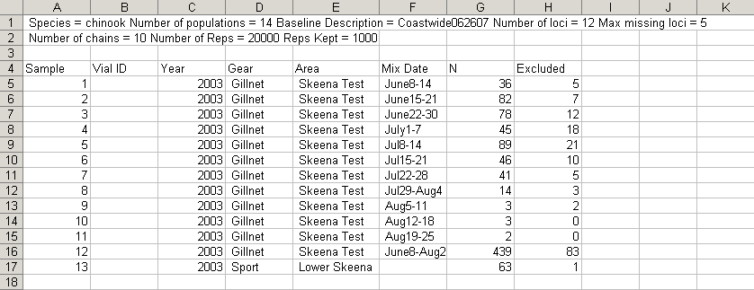

Stock composition reports

Each mixture is described in a header below which two columns report the estimated percent that each baseline population/region contributes to that mixture (Estimate described below) and the standard error of this estimate (SD described below). The header will provide information about the mixture such as area and date sampled, gear type, and sample size (number of individual fish grouped together for analysis). The sample size is the last row of the mixture header and will include in brackets the number of samples that were excluded from the analysis.

Stock proportion worksheet

Estimate: For each population in the baseline, the roll-up of the probabilities of all individual assignments to that population.
- Each individual fish has probability of being assigned to each population.
- For each population, the probability of being assigned to it is summed across all individual fish in the mixture
- For each population, the summed probability is divided by the total probability across all populations
- This results in estimates of population composition for each mixture that will sum to 100 across all populations
- Estimate is the estimated percent contribution of fish from that population to the mixture
- The estimated percent contribution of each population is reported, even if a given population is not estimated to contribute to the mixture at all (percent = 0.0)
- The contributing stocks will depend on the biology of the populations, and the time and area of sampling
SD: standard error of the mean of the estimated posterior (probability) distribution of that population’s contribution to the mixture.
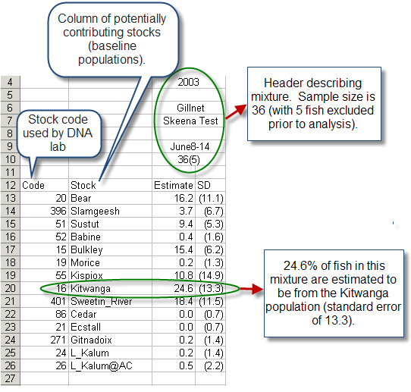
Regional worksheet

Estimate: For each regional grouping in the baseline, the roll-up of the probabilities of all individual assignments to that region.
- Each individual fish has probability of being assigned to each region
- For each region, the probability of being assigned to it is summed across all individual fish in the mixture
- For each region, the summed probability is divided by the total probability across all regions
- This results in estimates of region composition for each mixture that will sum to 100 across all regions
- Estimate is the estimated percent contribution of fish from that region to the mixture
- The estimated percent contribution of each region is reported, even if a given region is not estimated to contribute to the mixture at all (proportion = 0.0)
SD: standard error of the mean of the estimated posterior (probability) distribution of that region’s contribution to the mixture
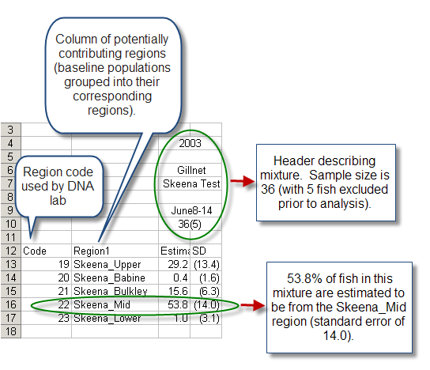
Individual IDs worksheet

At each MCMC chain iteration (i.e,. each time a sample is drawn from the posterior (probability) distribution) every individual fish in a mixture is assigned to one stock. These MCMC samples of stock assignments are summarized with the proportion of times each mixture individual was assigned to each stock. This is the probability of that individual belonging to a particular baseline population. For each mixture individual the top 5 individual assignments are reported, consisting of the name of the assigned stocks, the stock group or regional identification number, and the probability of assignment.

Although an assignment probability of each individual fish to each potentially contributing stock is calculated, results will only report the top five stocks each individual is assigned to (based on assignment probabilities). If less than five stocks are reported it is because that individual has no probability of assignment to any other stocks. There will be individuals with a high assignment probability to one stock, and low assignment probabilities to all other stocks. However, there will also be also be individuals with similar assignment probabilities to several stocks. These stocks are most likely genetically similar and thus difficult to discriminate.
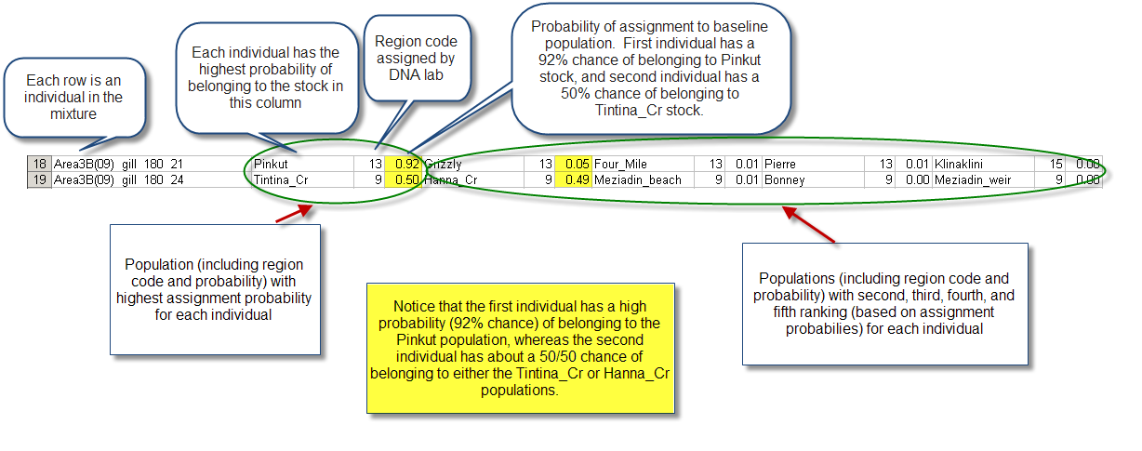

Individual Region IDs worksheet

Same as Individual IDs worksheet except individuals are assigned to regions instead of populations.
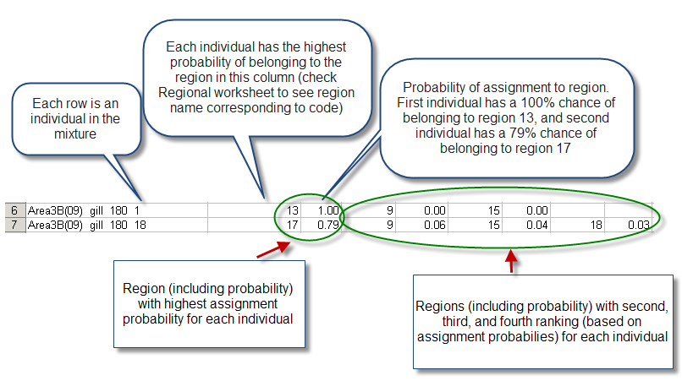

Gelman-Rubin worksheet
The Gelman and Rubin (G-R) convergence diagnostic is an estimate of chain convergence. The G-R diagnostic is the ratio of the variability of the pooled chains to the average variability within chains. The value should be close to 1, indicating that the variance within the chains is the same as the variance across chains, and values less than 1.2 are acceptable. A value greater than 1.2 is an indicator of poorly converged chains.
G-R diagnostics are provided for each stock and region composition estimate within a mixture (along with 97.5 quantile), in order to provide information on the chain convergence for each stock/region composition posterior (probability) distribution. There needs to be convergence prior to summarizing the distributions with estimates of stock composition.
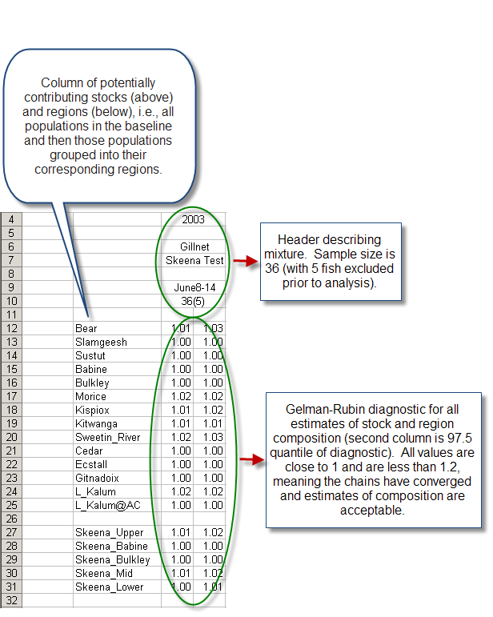

Key Considerations:

Sampling Design:

Important Assumption: The fish samples used in mixture analysis are assumed to be independent and a random and representative sample of the actual available population (the fish returning to an area during any given sampling period). Sampling design should ensure that individual fish of unknown stock of origin are sampled in a manner that ensures this assumption is met.

The percent composition of stocks captured in a fishery may not represent the true percent composition of stocks in the actual available population for reasons including gear selectivity, and various fisheries management measures (e.g., time/area closures, size/sex/species restrictions).

Thought should be given to sampling design in order to have a sufficient number of samples within each mixture. Mixtures are set up to include the individuals at a grouping level (area/time) of relevance for stock/region composition. Mixtures usually consist of individual fish samples from a given management unit (area and time period). For example, if the fishery is managed by area and month each mixture will consist of all individual fish sampled within a given area and month, and stock composition and individual IDs will be provided for this area and month. Sampling designs should be sure to include enough samples from each management unit to be assessed.

Main considerations:
- Independent, random and representative sample of actual population
- Sufficient sample size within each management unit

Probabilities of assignment to stock of origin:

A high probability of assignment to an individual stock usually occurs when the baseline population has a very distinct genotype. It also implies that there are enough samples from that baseline population to provide sufficient allelic frequency information to be able to discriminate easily between populations.

When an individual has a similar probability of assignment to numerous baseline populations, this means that the genetic information provided by the individual was not distinct enough to clearly discriminate between potential populations (these potential populations are generally genetically similar). Genetically similar populations are usually found in close proximity to each other, and there is most likely a high probability of assignment of that individual to the region containing these baseline populations. Lower assignment probabilities could also result when there are not enough samples from certain baseline populations to provide sufficient allelic frequency information to be able to discriminate between populations.

Baseline dependence of results:

Individual assignments to stock of origin and stock composition are dependent on the populations in the baseline. The results are the most likely composition of baseline populations found in the mixture. However, individuals can only be assigned to populations in the baseline, and the true stock of origin for individuals may not be included in the baseline. Individuals will then be assigned to the most likely population in baseline, usually a population in same region as the true stock of origin. It is important to have good baseline sampling in the area of interest (enough samples from enough populations to be useful).

Mixture dependence of results:

Individual assignments to stock of origin are also mixture dependent. Individual assignments are the probability of an individual belonging to a certain population given the genetic makeup of baseline populations and the genetic makeup of all individuals in the mixture. Therefore, individual assignments may be different if the same individual is included in different mixtures. This mainly applies to individuals with similar probabilities of assignment to numerous stocks. Those individuals with high probabilities of assignment to a particular stock will likely have the same stock assignment regardless of which mixture they are included in.

Individual assignments may change on each run of the model but the stock composition will generally not change between runs. Individual assignments are ranked based on the highest probability of assignment to a stock of origin, but for individuals with very similar probabilities of assignment to several baseline populations the rank order of stock assignments may change between model runs. Stock composition is a roll-up of all probabilities of individual assignments to baseline populations, regardless of which individuals are assigned to which population, and are thus more robust to replication.

